Experiment No:-

Name: Bhagyashree Rajgonda Patil Roll No: 27
Class: MCA SY Semester: 3rd
Subject: Mobile Application Development Batch: M2
Q) Implementation of Android Menus with Event Handling Using Option Menu, Context Menu, and Popup Menu.
- Option Menu

- activity_main.xml

<?xml version="1.0" encoding="utf-8"?>
<LinearLayout xmlns:android="http://schemas.android.com/apk/res/android"
xmlns:app="http://schemas.android.com/apk/res-auto"
xmlns:tools="http://schemas.android.com/tools"
android:id="@+id/main"
android:layout_width="match_parent"
android:layout_height="match_parent"
tools:context=".MainActivity"
android:orientation="vertical">

<androidx.appcompat.widget.Toolbar
android:id="@+id/toolbar"
android:layout_width="match_parent"
android:layout_height="?attr/actionBarSize"
android:layout_marginTop="24dp"
android:background="#5E27F5"
android:title="OptionsMenu"
android:titleTextColor="@color/white"
app:popupTheme="@style/ThemeOverlay.AppCompat.Light" />
</LinearLayout>

- MainActivity.java

package com.example.option_menu;

import android.os.Bundle;
import android.view.Menu;
import android.view.MenuItem;
import android.widget.Toast;
import androidx.appcompat.app.AppCompatActivity;
import androidx.appcompat.widget.Toolbar;
import androidx.core.content.ContextCompat;

public class MainActivity extends AppCompatActivity {

@Override
protected void onCreate(Bundle savedInstanceState) {
super.onCreate(savedInstanceState);

setContentView(R.layout.activity_main);

Toolbar toolbar = findViewById(R.id.toolbar);
setSupportActionBar(toolbar);
toolbar.setTitleTextColor(ContextCompat.getColor(this, R.color.white));

// Change overflow (three dots) icon color to white
if (toolbar.getOverflowIcon() != null) {
toolbar.getOverflowIcon().setTint(ContextCompat.getColor(this, R.color.white));
}
}

@Override
public boolean onCreateOptionsMenu(Menu menu) {
getMenuInflater().inflate(R.menu.option_menu, menu);
return true;
}

@Override
public boolean onOptionsItemSelected(MenuItem item) {
int id = item.getItemId();

if (id == R.id.search_item) {
Toast.makeText(this, "Search Selected", Toast.LENGTH_SHORT).show();
return true;
} else if (id == R.id.upload_item) {
Toast.makeText(this, "Upload Selected", Toast.LENGTH_SHORT).show();
return true;
} else if (id == R.id.copy_item) {
Toast.makeText(this, "Copy Selected", Toast.LENGTH_LONG).show();
return true;
}else if (id == R.id.print_item) {
Toast.makeText(this, "Print Selected", Toast.LENGTH_SHORT).show();
return true;
}else if (id == R.id.share_item) {
Toast.makeText(this, "Share Selected", Toast.LENGTH_SHORT).show();
return true;
}else if (id == R.id.bookmark_item) {
Toast.makeText(this, "Bookmark Selected", Toast.LENGTH_SHORT).show();
finish();
return true;
}
return super.onOptionsItemSelected(item);
}
}

- Option_menu.xml

<?xml version="1.0" encoding="utf-8"?>
<menu xmlns:android="http://schemas.android.com/apk/res/android">
<item android:id="@+id/search_item"
android:title="Search" />
<item android:id="@+id/upload_item"
android:title="Upload" />
<item android:id="@+id/copy_item"
android:title="Copy" />
<item android:id="@+id/print_item"
android:title="Print" />
<item android:id="@+id/share_item"
android:title="Share" />
<item android:id="@+id/bookmark_item"
android:title="BookMark" />
</menu>
- Output

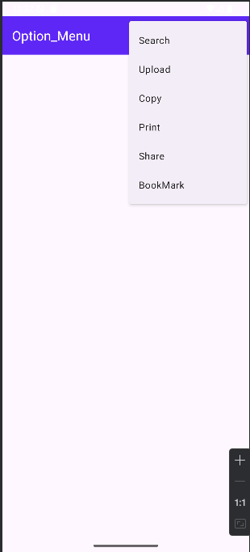 | 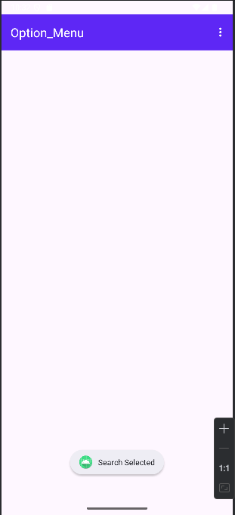

- Context Menu

- activity_main.xml

<?xml version="1.0" encoding="utf-8"?>
<LinearLayout xmlns:android="http://schemas.android.com/apk/res/android"
xmlns:app="http://schemas.android.com/apk/res-auto"
xmlns:tools="http://schemas.android.com/tools"
android:id="@+id/main"
android:layout_width="match_parent"
android:layout_height="match_parent"
android:orientation="vertical"
tools:context=".MainActivity">

<androidx.appcompat.widget.Toolbar
android:id="@+id/toolbar"
android:layout_width="match_parent"
android:layout_height="?attr/actionBarSize"
android:layout_marginTop="24dp"
android:background="#5E27F5"
android:title="ContextMenu"
android:titleTextColor="@color/white"
app:popupTheme="@style/ThemeOverlay.AppCompat.Light" />

<TextView
android:id="@+id/myTextView"
android:layout_width="wrap_content"
android:layout_height="wrap_content"
android:text="Long press me for context menu"
android:textSize="18sp"
android:textColor="@android:color/black"
android:padding="16dp" />
</LinearLayout>

- MainActivity.java

package com.example.context_menu;

import android.os.Bundle;
import android.view.ContextMenu;
import android.view.MenuInflater;
import android.view.MenuItem;
import android.view.View;
import android.widget.TextView;
import android.widget.Toast;
import androidx.appcompat.app.AppCompatActivity;
import androidx.appcompat.widget.Toolbar;
import androidx.core.content.ContextCompat;

public class MainActivity extends AppCompatActivity {

@Override
protected void onCreate(Bundle savedInstanceState) {
super.onCreate(savedInstanceState);

setContentView(R.layout.activity_main);

Toolbar toolbar = findViewById(R.id.toolbar);
setSupportActionBar(toolbar);
toolbar.setTitleTextColor(ContextCompat.getColor(this, R.color.white));

// Change overflow (three dots) icon color to white
if (toolbar.getOverflowIcon() != null) {
toolbar.getOverflowIcon().setTint(ContextCompat.getColor(this, R.color.white));
}

TextView MyTextView = (TextView) findViewById(R.id.myTextView);
registerForContextMenu(MyTextView);
}
@Override
public void onCreateContextMenu(ContextMenu menu, View v, ContextMenu.ContextMenuInfo menuInfo) {
super.onCreateContextMenu(menu, v, menuInfo);
MenuInflater inflater = getMenuInflater();
inflater.inflate(R.menu.context_menu, menu);
menu.setHeaderTitle("Choose Action");
}
@Override
public boolean onContextItemSelected(MenuItem item) {
int id = item.getItemId();

if (id == R.id.context_copy) {
Toast.makeText(this, "Copy clicked", Toast.LENGTH_SHORT).show();
return true;
} else if (id == R.id.context_paste) {
Toast.makeText(this, "Paste clicked", Toast.LENGTH_SHORT).show();
return true;
}
return super.onContextItemSelected(item);
}
}

- Context_menu.xml

<?xml version="1.0" encoding="utf-8"?>
<menu xmlns:android="http://schemas.android.com/apk/res/android">
<item android:id="@+id/context_copy"
android:title="Edit" />
<item android:id="@+id/context_paste"
android:title="Delete" />
</menu>

- Output

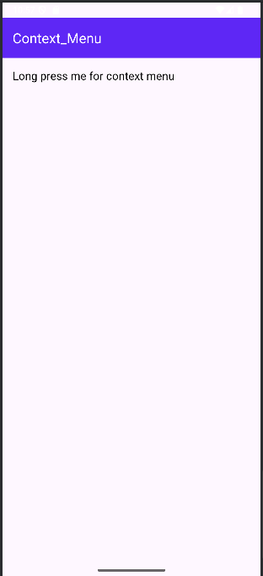 | 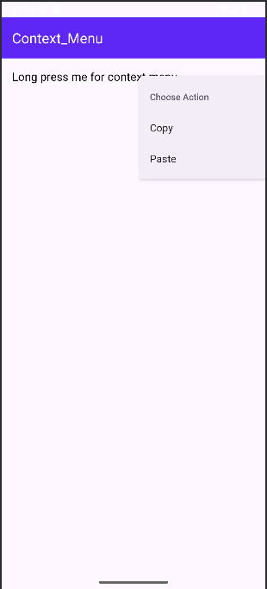

- Popup Menu

- activity_main.xml

<?xml version="1.0" encoding="utf-8"?>
<LinearLayout xmlns:android="http://schemas.android.com/apk/res/android"
xmlns:app="http://schemas.android.com/apk/res-auto"
xmlns:tools="http://schemas.android.com/tools"
android:id="@+id/main"
android:layout_width="match_parent"
android:layout_height="match_parent"
android:orientation="vertical"
tools:context=".MainActivity">

<androidx.appcompat.widget.Toolbar
android:id="@+id/toolbar"
android:layout_width="match_parent"
android:layout_height="?attr/actionBarSize"
android:layout_marginTop="24dp"
android:background="#5E27F5"
android:title="PopupMenu"
android:titleTextColor="@color/white"
app:popupTheme="@style/ThemeOverlay.AppCompat.Light" />

<Button
android:id="@+id/showPopupButton"
android:layout_width="wrap_content"
android:layout_height="wrap_content"
android:text="Show Popup Menu"
android:layout_gravity="center_horizontal" />

</LinearLayout>

- MainActivity.java

package com.example.popup_menu;

import android.os.Bundle;
import android.view.MenuItem;
import android.view.View;
import android.widget.Button;
import android.widget.Toast;
import androidx.appcompat.app.AppCompatActivity;
import androidx.appcompat.widget.PopupMenu;
import androidx.appcompat.widget.Toolbar;
import androidx.core.content.ContextCompat;

public class MainActivity extends AppCompatActivity implements PopupMenu.OnMenuItemClickListener{

@Override
protected void onCreate(Bundle savedInstanceState) {
super.onCreate(savedInstanceState);

setContentView(R.layout.activity_main);

Toolbar toolbar = findViewById(R.id.toolbar);
setSupportActionBar(toolbar);
toolbar.setTitleTextColor(ContextCompat.getColor(this, R.color.white));

// Change overflow (three dots) icon color to white
if (toolbar.getOverflowIcon() != null) {
toolbar.getOverflowIcon().setTint(ContextCompat.getColor(this, R.color.white));
}

Button btn = (Button) findViewById(R.id.showPopupButton);
btn.setOnClickListener(new View.OnClickListener() {
@Override
public void onClick(View v) {
PopupMenu popup = new PopupMenu(MainActivity.this, v);
popup.setOnMenuItemClickListener(MainActivity.this);
popup.inflate(R.menu.popup_menu);
popup.show();
}
});

}
@Override
public boolean onMenuItemClick(MenuItem item) {
int itemId = item.getItemId();
Toast.makeText(this, "Selected Item: " + item.getTitle(), Toast.LENGTH_SHORT).show();

if (itemId == R.id.search_item) {
Toast.makeText(this, "Search clicked", Toast.LENGTH_SHORT).show();
return true;
} else if (itemId == R.id.upload_item) {
Toast.makeText(this, "Upload clicked", Toast.LENGTH_SHORT).show();
return true;
} else if (itemId == R.id.copy_item) {
Toast.makeText(this, "Copy clicked", Toast.LENGTH_SHORT).show();
return true;
} else if (itemId == R.id.print_item) {
Toast.makeText(this, "Print clicked", Toast.LENGTH_SHORT).show();
return true;
} else if (itemId == R.id.share_item) {
Toast.makeText(this, "Share clicked", Toast.LENGTH_SHORT).show();
return true;
} else if (itemId == R.id.bookmark_item) {
Toast.makeText(this, "Bookmark clicked", Toast.LENGTH_SHORT).show();
return true;
} else {
return false;
}
}
}
- Popup_menu.xml

<?xml version="1.0" encoding="utf-8"?>
<menu xmlns:android="http://schemas.android.com/apk/res/android">
<item android:id="@+id/search_item"
android:title="Search" />
<item android:id="@+id/upload_item"
android:title="Upload" />
<item android:id="@+id/copy_item"
android:title="Copy" />
<item android:id="@+id/print_item"
android:title="Print" />
<item android:id="@+id/share_item"
android:title="Share" />
<item android:id="@+id/bookmark_item"
android:title="BookMark" />
</menu>

- Output

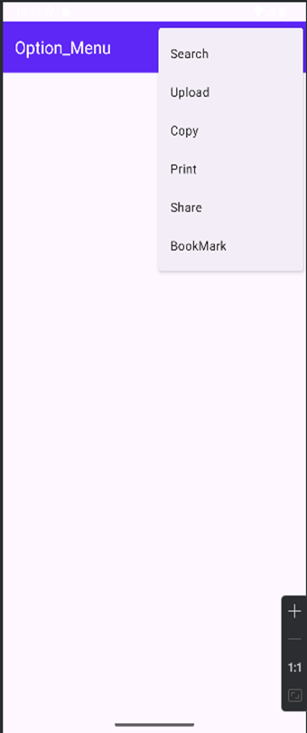 | 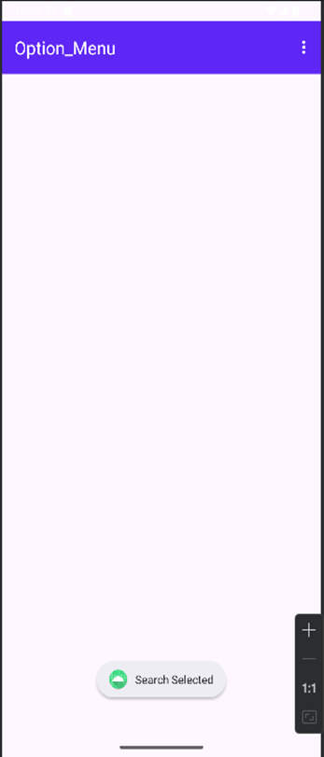

Cognitive (04) | Psychomotor Skill (04) | Affective Domain (02) | Total (10) | Sign

